Welding Nails Demo Presenter: Andy Jackson Harrisonburg City Schools ajackson@harrisonburg.k12.va.us

Va. SOL:
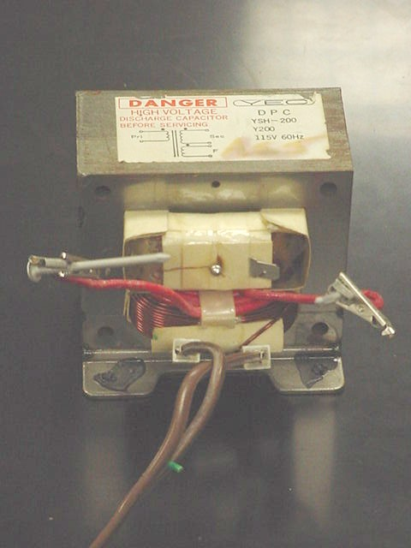
PH.11 The student will investigate and understand how to diagram, construct, and analyze basic electrical circuits and explain the function of various circuit components. Key concepts include
- Ohm’s law;
- series, parallel, and combined circuits;
- electrical power; and
- alternating and direct currents.

Topic/Concept
Applying Ohm’s Law to the concept of electrical shock. Helping students to understand that it is neither voltage nor current that is inherently dangerous, but the three variable relationship in Ohm’s Law.

Materials
- High current step-down transformer
- Aluminum nails
- Trusting teacher

Safety Considerations- EXTREME – PAY ATTENTION TO THESE NOTES AND ONLY PROCEED IF YOUR BACKGROUND AND TRAINING MAKES YOU COMFORTABLE DOING THIS.
It is essential that the A.C. Open circuit Voltage of the output be less than ~6 Volts to prevent shocking the teacher. The short circuit current should be very large to make dramatic sparking of the nails. The nails must not be allowed to be in contact for more than fractions of a second to prevent welding together and throwing of circuit breaker or fire hazard with transformer. DO NOT ATTEMPT IF YOU ARE UNSURE OF THESE PARAMETERS.

When dissecting a microwave oven be extremely careful of charged capacitors – there are extremely large capacitances involved in powering the magnetron.

Directions in this handout alone are NOT enough to keep you safe – Your safety depends on YOUR background, training and caution.

Presentation
Make sure the nails are not touching each other or any other objects. Plug in the power cord. Manipulate the nails by the insulating electrical tape. Bring them to touch each other lightly. SPARKS WILL FLY! Do not allow them to touch for long or they will weld together and you will (hopefully) blow a fuse, or have a meltdown of your transformer. After the nails are apart again, allow them to cool. Ask the class what would happen if you touched one of the nails while it was plugged in. Do it. Ask what would happen if you touched both nails while it was plugged in. Do it. Touch the nails together again to show the students it is still “live”.

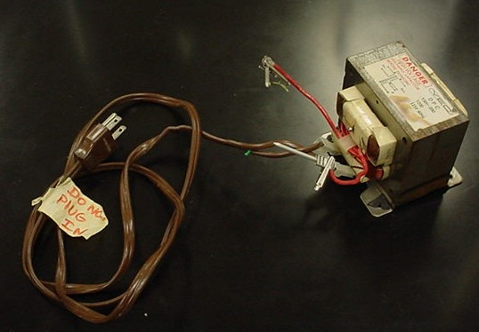

How the physics is demonstrated

Students understand intuitively that when the sparks fly there is “lots of electricity”. When asked what will happen if I touch it there are a variety of responses. I reach out and touch ONE nail. Some student are surprised it doesn’t shock me. They call for me to touch BOTH nails. I then touch both nails – one at a time. The students object and say that is NOT what they meant. I then touch both nails simultaneously and show that I am not shocked. I then ask them why when I touch them there is not a shock, but when the nails touch together there is such a dramatic amount of electricity. This allows for a good conversation about V = I R and the term “grounded” in electricity. Many students believe I am not shocked either because I am grounded or because I am not grounded.

Since the Open circuit voltage is ~ 3 V and my resistance on a given day may be ~ 100,000 W. The current flowing through me is 0.03 mA. For the human body the following chart is roughly true;
1 mA – feel it
10 mA – painful with involuntary muscle contractions
100 mA – through the chest is likely to cause fibrillations and likely death
1000 mA – causes third degree burns

Since the aluminum nails have a TINY resistance – likely less than 1 W, the current flowing through them is greater than 3 A

Construction and Tips Regarding the Demonstration

Salvage a transformer from a microwave oven. Make sure you pay attention to my safety warnings above. Both transformers that I have salvaged act as a step-up and step-down transformer. If this is the case, there will be three sets of coils attached to six different connections in the oven. Modify a power cord so you can have a electrical plug on one end and bare wires on the other. Connect the bare wires to the set of coils that has the medium number of turns. Attach by electrical tape two aluminum nails to the leads coming from the coil with the smallest number of turns. The ratio of turns of the primary to the secondary is the factor which the voltage will be stepped down and the current will be stepped up.

Sources & References

The Purpose of the High Voltage Transformer Used in Microwave Ovens and How to Safely Test this High Voltage Component
http://www.gallawa.com/microtech/xformer.html

How a transformer works http://www.physlink.com/education/askexperts/ae427.cfm

