Frictions Presenter: Andy Jackson Harrisonburg City Public Schools
ajackson@harrisonburg.k12.va.us

Va. SOL:
PH.1 The student will plan and conduct investigations using experimental design and product design processes. Key concepts include
- the components of a system are defined;
- instruments are selected and used to extend observations and measurements;
- information is recorded and presented in an organized format;
- the limitations of the experimental apparatus and design are recognized;
- the limitations of measured quantities are recognized through the appropriate use of significant figures or error ranges;
- models and simulations are used to visualize and explain phenomena, to make predictions from hypotheses, and to interpret data; and
- appropriate technology, including computers, graphing calculators, and probeware, is used for gathering and analyzing data and communicating results.

PH.2 The student will investigate and understand how to analyze and interpret data. Key concepts include
- a description of a physical problem is translated into a mathematical statement in order to find a solution;
- relationships between physical quantities are determined using the shape of a curve passing through experimentally obtained data;
- the slope of a linear relationship is calculated and includes appropriate units;
- interpolated, extrapolated, and analyzed trends are used to make predictions; and

Topic/Concept
Static and kinetic friction, coefficient of friction, considering error in measurements through a statistical treatment

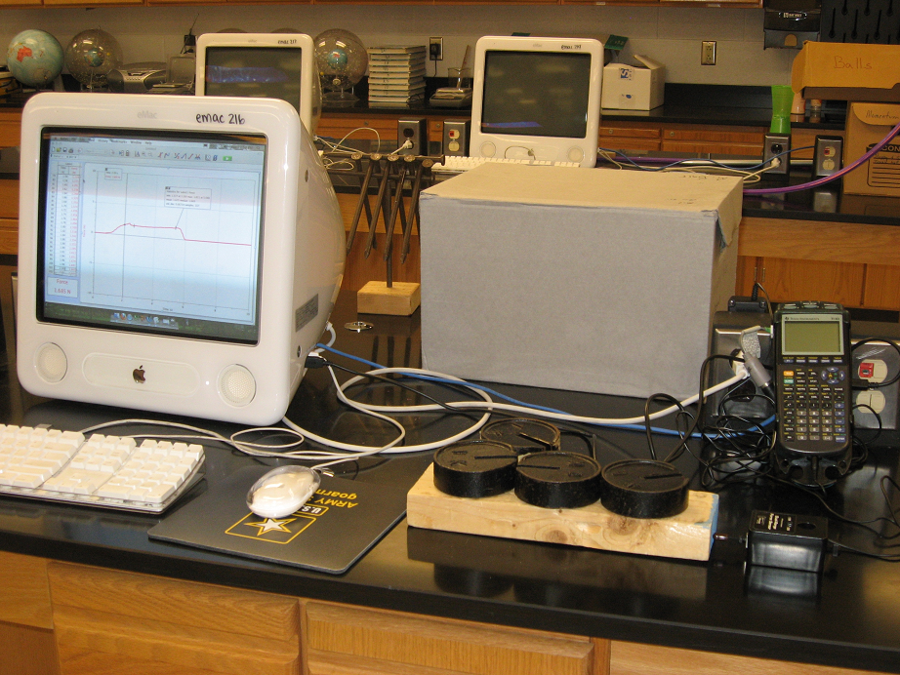
Materials
Wooden block, force proble, 1 kg masses, Vernier dual range force probe, LabPro, Computer, LoggerPro

Safety Considerations
Heavy masses that can tip and fall

Presentation

Frictions

A gem cannot be polished without friction, nor a man perfected without trials.
Lucius Annaeus Seneca I

Introduction
When students begin to study Newton’s 1st law the idea of “an object in motion staying in motion” is a difficult concept. This is due to our every day experience of seeing objects that are set in motion grinding to a halt if we don’t keep pushing them. This acceleration (remember, slowing down is accel. also) is caused by friction. When students begin to study Newton’s 2nd law the presence of friction as an additional force also can cause some confusion. Since in our daily experience friction is an unavoidable fact of life it is necessary to understand how it operates. There are three basic types of friction; rolling friction, sliding friction, and static friction. Rolling friction as you might guess concerns objects that roll or have wheels. ( a cart rolling across a table) Sliding friction concerns objects that have no wheels moving across another surface. (a book sliding across a table) Static friction is the friction that exists between two surfaces that are not moving relative to each other. ( a book that is at rest on a table and is being pushed by your hand but is not sliding yet)
All three types of friction can be described by a term called the coefficient of friction. This term has the symbol μ which is a Greek letter and is pronounced “mu”. It is a ratio of the frictional force on an object to the support force provided by the surface on which it rests. This support force is called the normal force and is always perpendicular to the surface on which the object rests. The equation then is μ ₌ Ff
Fn
Equipment
Wooden block and 4 1 kg masses
LabPro
Laptop with LoggerPro
+/- 50 N force probe
DIN adaptor
Procedure
Hook it all up. Teacher will demonstrate set up. The force probe needs an adaptor to plug into the LabPro. Make sure the force probe is switched into the +/- 50 N mode.
The force probe must be calibrated. To do this follow the prompts on the Lab WhiteBoard. Use 0 N as the one point calibration.
After calibration you are ready to collect data.

Experiment Procedure

Put the wooden block on the table.
Choose a time for your experiment that will allow you to gradually increase the pushing force until the block begins to slide and then push it with a constant velocity for a little while.

√ for a good trial. If you have done it well, your graph will look something like this

Use LoggerPro tools to analyze the data to determine the following things:
1- the maximum amount of friction
2 - the average amount of friction while the block is sliding.
3 - the uncertainty in the sliding friction.

Conduct 3 trials of each mass and record the data in an organized data table.

Evaluation
For each of the following questions, site evidence from your data that supports your answer. Include uncertainty in your thinking.

1. Does the force of sliding friction change as weight is increased?

2. Does the value of μ sliding change as weight is increased?

3. Does the force of static friction change as weight is increased?

4. Does the value of μ static change as weight is increased?

5. For an object of a given weight which type of friction is the greatest?

6. Create a graph of Sliding Friction Vs Normal Force. Make a column of sliding force uncertaninty and I’ll show you how to make error bars. Create the best fit straight line and tell me what the graph and slope mean.

Teacher Tips Regarding Lab

The graph above was a trial of for a wooden block m = 424.6 g with 3 1.0 kg masses on it. In this trial Examine was used to find the Static friction of 1.972 N . The lower, nearly horizontal segment of the graph was while the block was sliding at constant speed. This section was highlighted and the Statistics function was chosen. The average force was 1.670 N with a standard deviation of 0.06714 N over 137 data points. The standard deviation of the mean was 0.06714 N / $\sqrt{\text{137}}$ = 0.0057 N Therefore the kinetic friction was 1.670 + 0.006 N

Within error the static friction and kinetic friction forces should increase with weight on the block, but the coefficients of frictions should stay relatively constant. Due to uncertainties in frictional force, the constancy of the coefficients is not obvious to all students. The slope of the Ff vs Fn yields the coefficient of kinetic friction.

Sources & References

